VISVESVARAYA TECHNOLOGICAL UNIVERSITY

Jnana Sangama, BELAGAVI - 590018
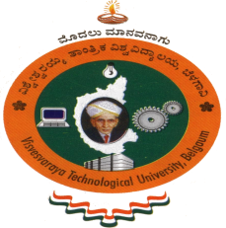

Internship Report
On
------------------------------------------------------------------------
MACHINE LEARNING IN PYTHON

Submitted in partial fulfillment of the requirements as prescribed by the Visvesvaraya Technological University for the award of degree of
Bachelor of Engineering
in
ELECTRONICS and COMMUNICATION

Submitted by:

Name: MALLIKARJUN GOKAK
USN: 1SK17EC022

Internship Carried out at:
AIRobotica Services Pvt.Ltd, Bengaluru


Department of Electronics and Communication Engineering
Govt. Sri Krishnarajendra Silver Jubilee Technological Institute
K.R. Circle, Bengaluru-560001

2020-2021
GOVERNMENT SRI KRISHNARAJENDRA
SILVER JUBILEE TECHNOLOGICAL INSTITUTE
K.R. Circle, Bangalore -560001
Department of Electronics and Communication Engineering

C E R T I F I C A T E

This is to certify that the Internship Report entitled “MACHINE LEARNING” is a bonafide work carried out by MALLIKARJUN GOKAK (USN: 1SK17EC022) of VIII Semester (B.E), in partial fulfillment of the requirements for the award of degree of Bachelor of Engineering in Electronics and Communication Engineering of the Visvesvaraya Technological University, Belagavi during the academic year 2020-21. The Internship Report has been approved as it satisfies the academic requirements in respect of Internship work prescribed for the said degree.

Signature:

Guide HOD PRINCIPAL

External Viva Voce
Name of the Examiner | Signature with Date
1.
2.

Total Marks | Marks Obtained
50

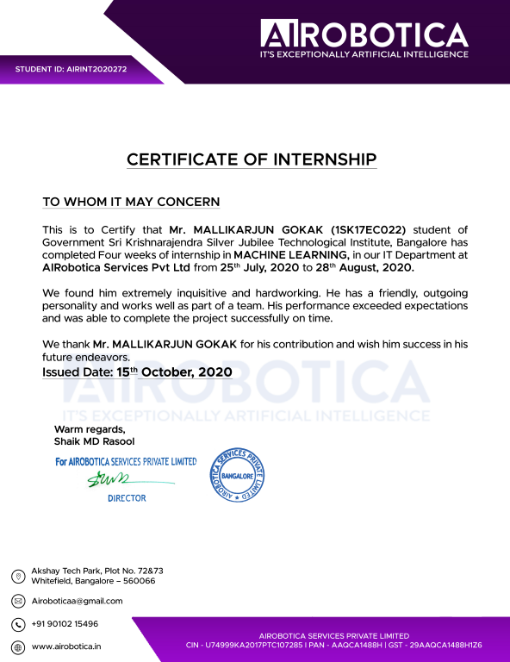

ACKNOWLEDGEMENT
A unique opportunity like this comes very rarely. It is indeed a pleasure for me to work. The satisfaction that accompanies the successful completion of this project is incomplete without the mention of the people whose guidance has made possible for me to complete this project.
I sincerely thank Visvesvaraya Technology University for providing a platform to do the internship work.
I express my sincere thanks to Dr. K G Chandrashekhara, Principal, Government Sri Krishnarajendra Institute of Technology, Bengaluru, for providing necessary facilities and motivation to carry out internship work successfully.
I express heartfelt gratitude and humble thanks to my internal guide Dr. Rangaraju H G, Head of Department, Government Sri Krishnarajendra Institute of Technology, for the constant encouragement, inspiration and help to carry out internship work successfully.
I am very thankful to my external guide Mr. Shaik MD Rasool, project manager, at AIRobotica Services who has given me in-time valuable instructions and put me in contact with experts in the field, with extensive guidance regarding many practical issues.
I thank Prof. Mamatha R, Assistant Professor, internship coordinator for her boundless cooperation and help extended during this internship work.
I am thankful to all the teaching and non-teaching staff members of Electronics & Communication Engineering Department for their help and needed support rendered throughout the internship.
MALLIKARJUN GOKAK
1SK17EC022

ABSTRACT
Machine Learning is an emerging technology, and it has wide range of applications in a real world. Machine Learning is used in various fields such as Online Customer Support, Social Media Services, Healthcare, Videos Surveillance, Virtual Personal Assistants, Online Fraud Detection, Product Recommendations and many more. Machine Learning is a subfield of Artificial Intelligence, which enables machines to learn from past data or experiences without being explicitly programmed. In modern world large amount of data available everywhere. Therefore, it is required to analyze this data to extract some useful information for futuristic enhancement, this can be achieved by Data Mining and Machine Learning algorithm-based models.
In this Internship period, I have Explored and worked on some Machine Learning Libraries and Algorithms to develop a Model using python and developed Diabetes Prediction for Diabetes Data Model in Bangalore. Which gave hands on experience, involved in problem solving and developing Machine Learning project.

TABLE OF CONTENTS
CONTENTS Page No.
Chapter 1: COMPANY PROFILE 1
1.1 Company Services 1
1.2 Directors 1
CHAPTER 2: ABOUT THE COMPANY 2
2.1 Vision 2
2.2 Mission 2
CHAPTER 3: INTRODUCTION 3-17
3.1 Python 3
3.1.1 Characteristics of Python 3
3.1.2 Applications of Python 4
3.2 Machine Learning 5
3.2.1 Classification of Machine learning 6
3.2.2 How machine learning works 8
3.2.3 Applications of Machine Learning 9
3.3 Artificial Intelligence 10
3.3.1 Applications of AI 11
3.4 Data Visualization 12
3.5 Data Cleansing 12
3.5.1 Removal of unwanted observations 13
3.5.2 Fixing Structural errors 13
3.5.3 Managing Unwanted outliers 14
3.5.4 Handling missing data 14
3.6 Machine Learning Model 14
3.6.1 Defining the problem 15
3.6.2 Data Collection 15
3.6.3 Preparing the Data 15
3.6.4 Assigning Appropriate Model/ Protocols 15
3.6.5 Training the Machine Model or “The Model Training” 16
3.6.6 Evaluating and Defining Measure of Success 16
3.6.7 Parameter Tuning 16
3.7 Dataset 16
3.7.1 CSV File 16
3.8 Terminologies 17
CHAPTER 4: TASK PERFORMED 18-25
4.1 Weekly Progress 18
4.2 Project Description 19
4.2.1 Problem Statement 19
4.2.2 Implementation 19
4.2.3 K-Nearest Neighbour (knn) Algorithm 20
4.2.4 Performance Evaluation Matrix 21
4.2.5 Results and Discussion 23
4.2.5.1 Dataset 23
4.2.5.2 Experiment Platform 23
4.2.5.3 Results 24
CHAPTER 5: REFLECTION 26-28
5.1 Work Experience 26
5.2 Problems/Challenges 26
5.3 Technical Outcomes 26
5.4 Non-Technical Outcomes 27
5.5 Reason for choosing Machine Learning 27
5.5.1 Career Opportunities 27
5.5.2 Jobs on the rise 27
5.6 Benefits of Doing an Internship 28
5.6.1 Gain Valuable Work Experience 28
5.6.2 Have an Edge in the Job Market 28
5.6.3 Transition into a Job 28
5.6.4 Machine Learning Opportunities 28
CHAPTER 6: CONCLUSION 29
REFERENCES 30

LIST OF FIGURES
3.1 Classifications of Machine Learning 6
3.2 Clustering example 6
3.3 Classification and Regression 7
3.4 Machine Learning Process 8
3.5 Applications of Machine Learning 10
3.6 Relationship between AI, ML and DL 11
3.7 Data Cleansing steps 13
4.1 Proposed Model Diagram 20
4.2 k-NN Classifier 21
4.3 Confusion matrix 21
4.4 Snapshot of Dataset 23
4.5 Accuracy plot 24
4.6 Snapshot of output Confusion matrix and values of matrices 24
4.7 Snapshot of resulted AUC and ROC curve 25
4.8 ROC area of Predicted Diabetes using k-NN algorithm 25

